SpaceBalls

By Team 6: Ajai Gorowara, Christopher Reece, Travis Qing, Tyler Washington & Joshua Day

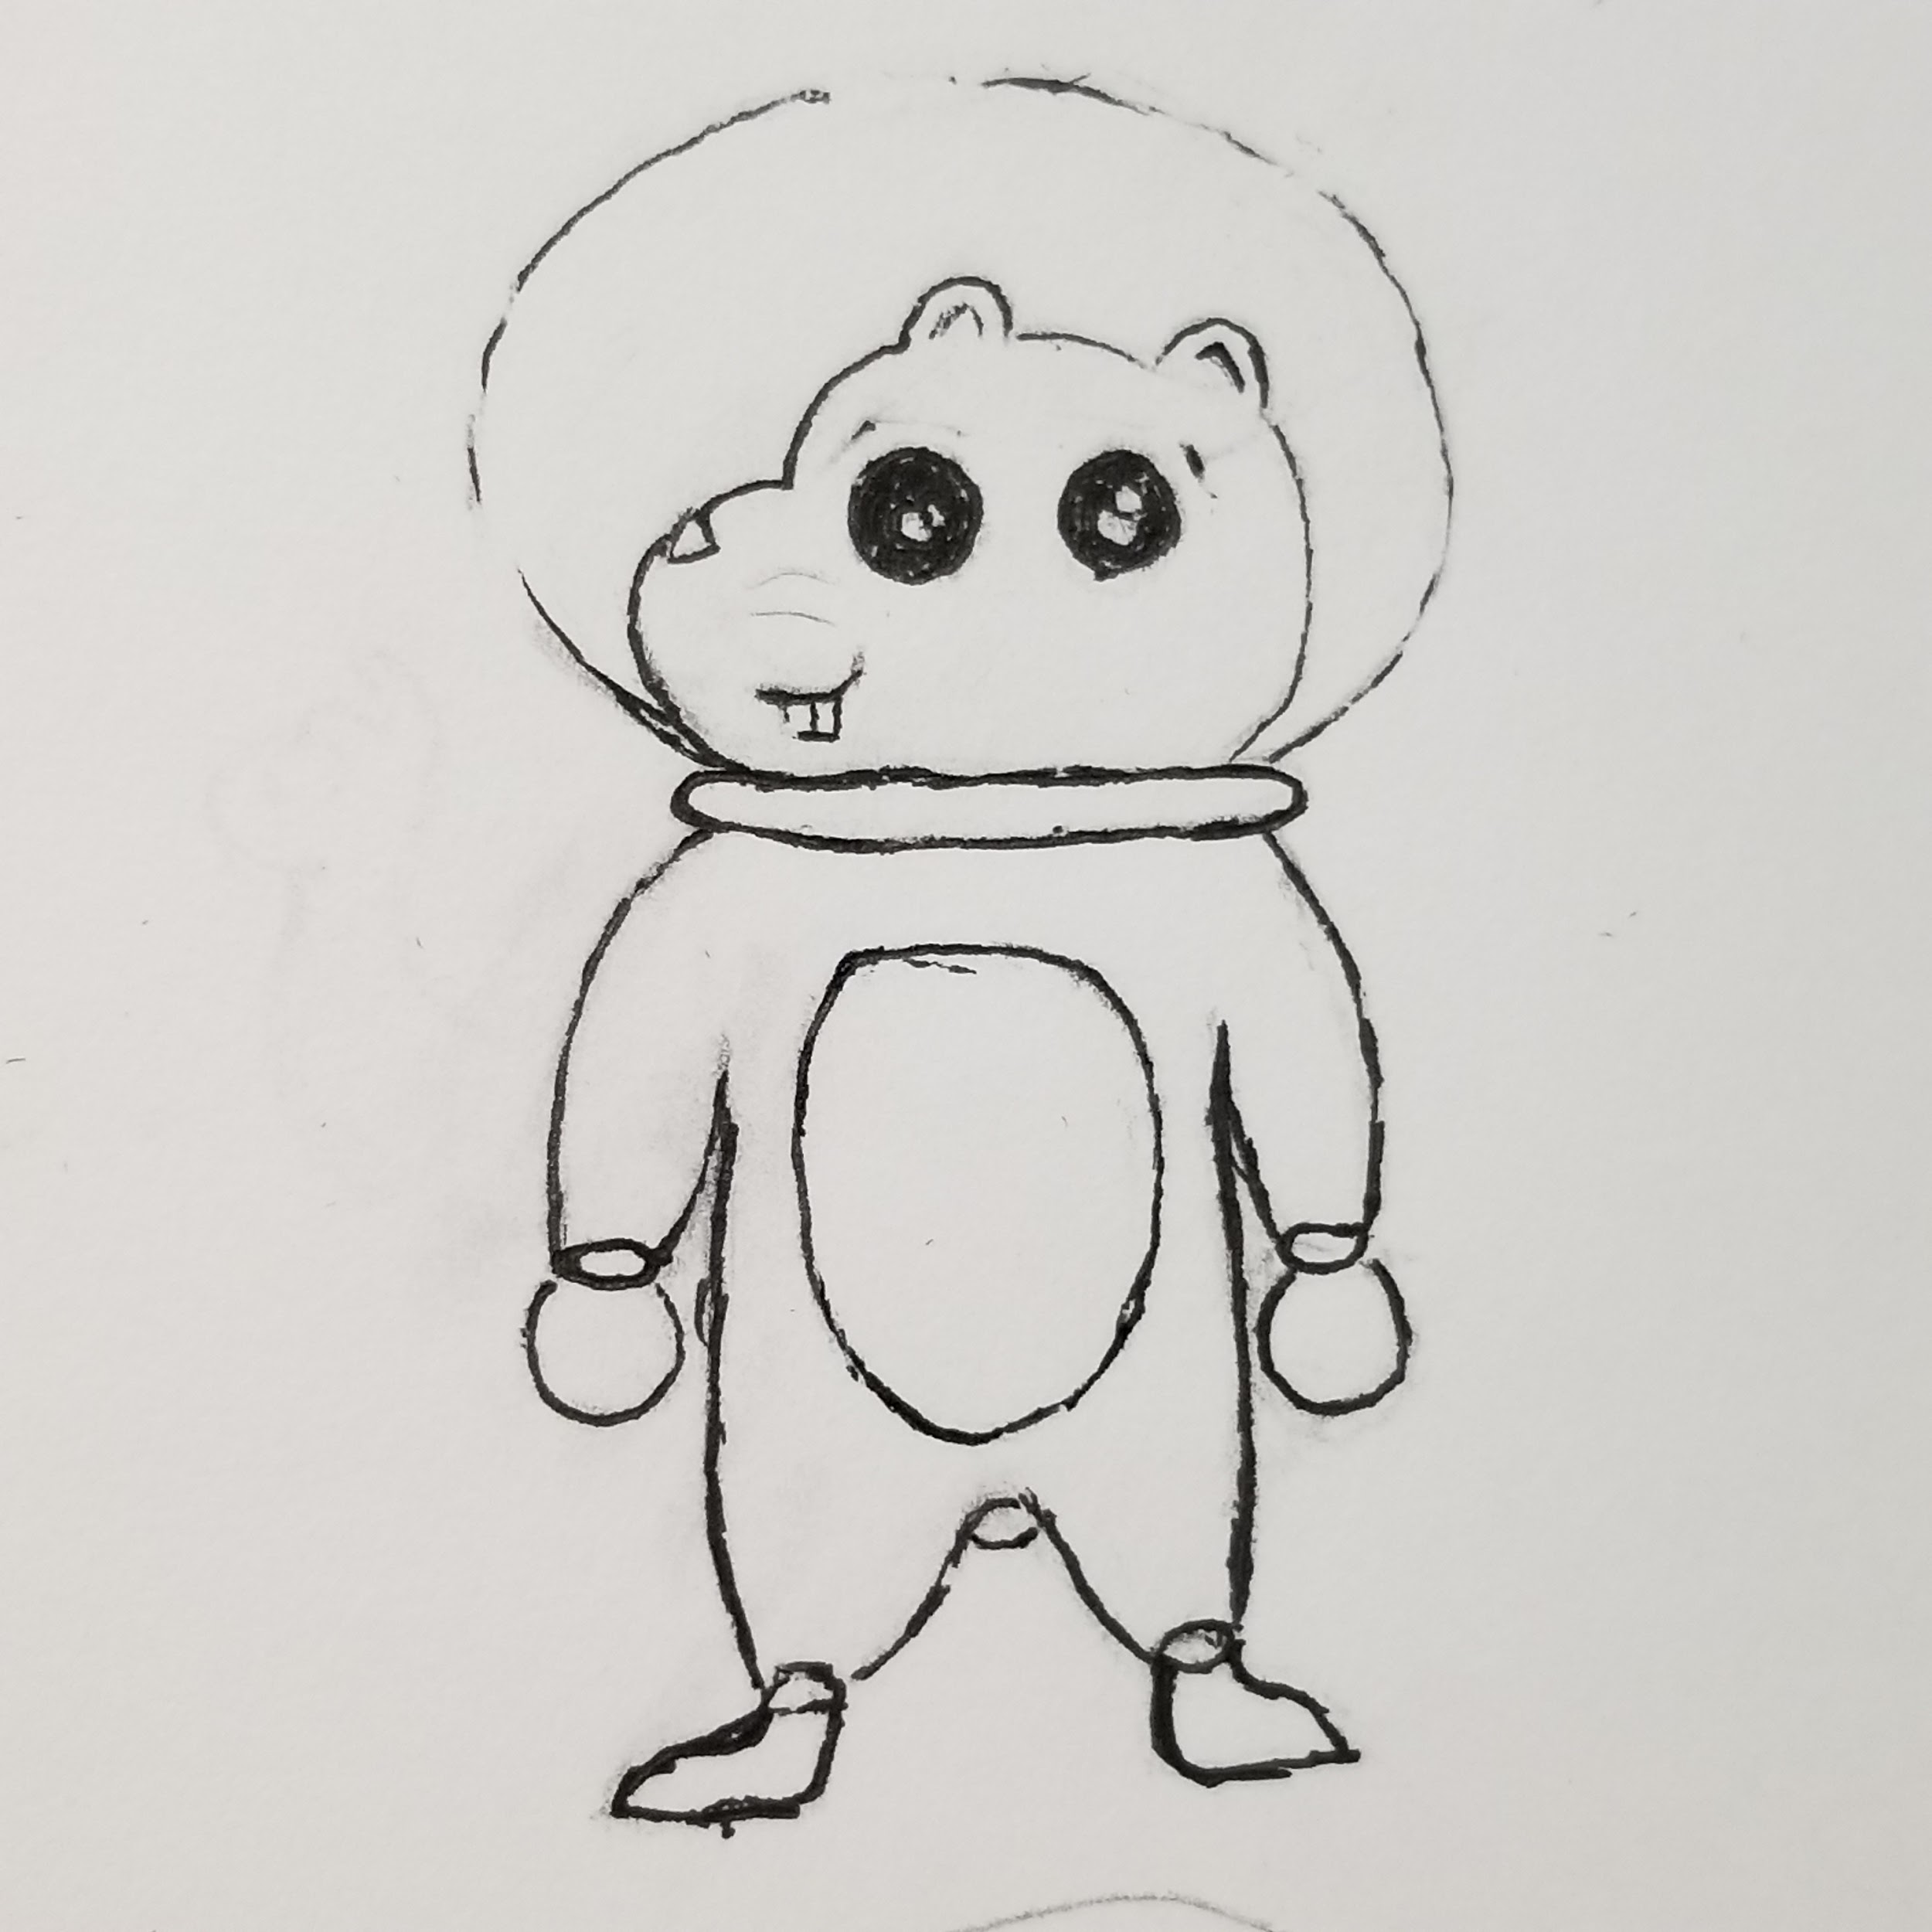

# Table of Contents

**Table of Contents**2

**Core Concept**3

Two Sentence Pitch 3

Two Minute Pitch 3

**Gameplay Overview**3

Level Design 3

Level Gameplay 4

Goal 4

Player Control 4

Collectables 5

**Mechanics**5

Tilt Mechanic 5

Goal 6

Moving Platforms 7

Timer 7

Bounce Platform 8

Leaderboard 8

**Theme and General Look**8

Theme 8

Artstyle 9

**Game Flow**10

Menu Flow Diagram 10

Level Mock Up Example 11

Title Screen 11

Level Set Screen 11

Level Select Screen 11

**Approximate Timeline and Milestones**12

Week 1 12

Week 2 12

Week 3 12

Week 4 12

**Team Bio and Expected Contributions**13

# Core Concept

## Two Sentence Pitch

Spaceballs is a physics-based game allowing you to be the best hamster captain in space by gathering crystals faster than your Cricetinae competitors. Rather than chasing after crystals, you move the world to bring the crystals to you and then make it to the goal.

## Two Minute Pitch

SpaceBalls is a physics-based arcade platformer. Rather than moving the player object around each level, the player can directly tilt the entire stage, allowing for the player object to move. The player is tasked with completing each level as fast as possible, while collecting collectables to increase their overall score. This physics-based approach makes the game like a labyrinth tilt-maze game.

Somewhere in outer space, there exists a species of Space Hamsters that value their collection of space ball crystals. You, as the cute and chubby Captain Chunky, must go on a mission to collect as many more crystals in the Platform Galaxy than the other space rodents. By collecting these crystals faster than the others, it will increase the reputation of you, Captain Chunky and earn your spot on the Leaderboard. Being on this exclusive list will show all the rest of the hamsters that you are the most prestigious and honored of the entire space hamster species. Collect as many crystals as you can, as fast as you can to be on the Leaderboard and become the most renowned space hamster captain.

# Gameplay Overview

## Level Design

Each level design will be based on the area that the level takes place in, and there will be three sets of levels, with five levels per set, each containing different designs that represent the set’s theme. While the core mechanics that are needed to control the player object will not change, each level will be different structurally. Each stage will be set up so that the player must roll through obstacles such as holes and bumps and other obstacles to reach the goal point, allowing them to advance towards the next stage. The first set will be an introduction to the game, teaching the player the core mechanics of the game. While in sets two and three, the levels will get progressively harder as they go on, testing the player by introducing new ideas and ways to complete each level. When the player finishes each level, the player will give a score based on their performance in a level, and the player will be able to choose to continue to the next level or return to the level select screen.

## Level Gameplay

When the player clicks on a level in the level select screen, the player will be loaded into that level. The level begins the moment the player spawns into the level. The player will be spawned on an even surface, as to avoid the player object from moving. The player can control the tilt of the stage using the WASD keys. At this point the player must get through the level without falling off the stage. When the player object passes through the goal, the player has then completed that level. The player has 60 seconds to complete each level.

When the player falls off the stage, the level resets and the player will have to start from the beginning of the level. If the timer hits zero in the level, the level will reset and the player will have to start from the beginning of the level.

## Goal

The goal of each level is to get the highest score possible for each level. This is based on several factors, such as getting time, collectables. The player must get to the end of each level within the time limit and without falling off the stage. At the end of the game, when all the levels are completed, the player receives a high score which they can post online.

## Player Control

**Tilting the Stage** - The player uses the WASD keys to tilt the stage relative to both the player’s location and the direction of the camera. The W, A, S, and D keys tilt the platform forwards, backwards, to the left, and to the right respectively. These keys can be used in combination with each other to tilt the stage in the direction of the pressed keys. For example, pressing the W and A key results in the stage being tilted forward and to the left. The tilt of the stage increases over time as one of these keys are held, and the tilt of the stage returns to zero when no keys are held. This allows for minute adjustments in tilt by tapping one of these keys.

**Moving the Player** -

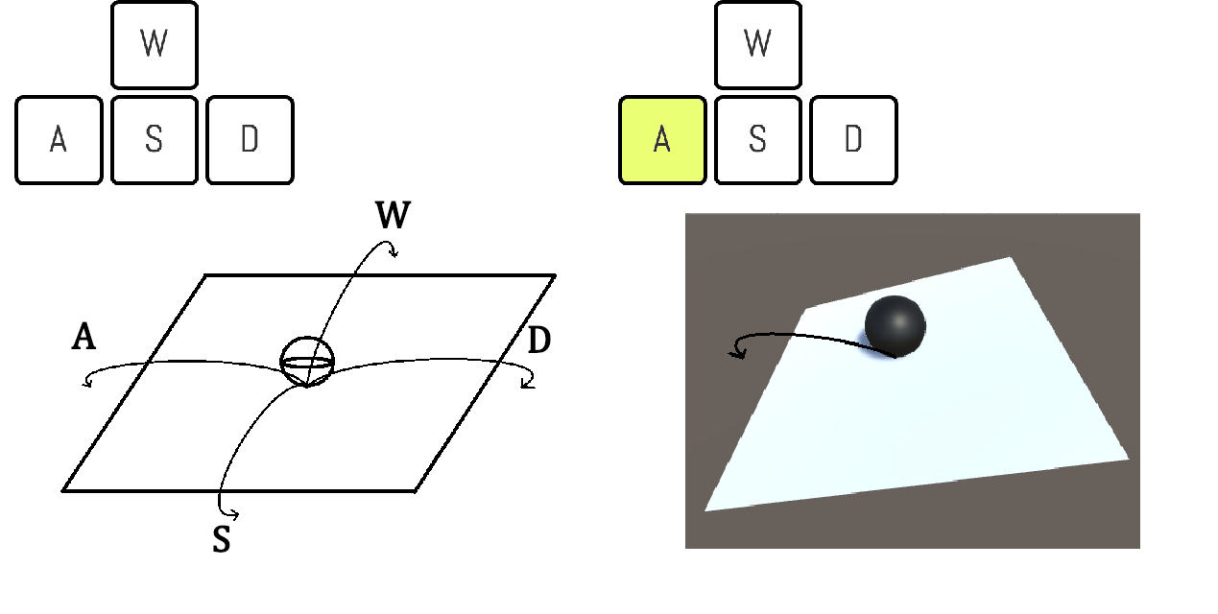

*Concept of tilt control*

## Collectables

**Crystals** - Within the levels, the player will see different crystals that they can collect. These crystals are collectables that count 400 points each towards the players total score. The player can collect these during the levels, and there are a limited amount for each level. These are optional and the player can bypass these in favor of getting a better time score. However, it is more score-effective to collect gems than to save time.

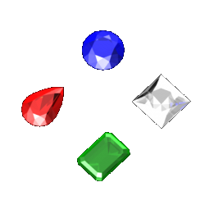

*Example of collectable crystals*

**Clocks** - The player will encounter a limited number of clocks in levels. When a clock is collected in a level, 20 seconds are added to the current time on the timer. They also give the player 500 points.

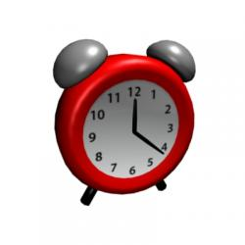

*Example of collectable clock*

# Mechanics

## Tilt Mechanic

In each level, the player can move the player object around by tilting the entire stage. A stage is defined as the platforms that the player objects rests on. The tilt mechanic changes the player object from a resting state to an active state. The player resting state is defined as when the player first spawns into the level and is not moving. The players active state is defined when the player object is in motion. The player can control the tilt axis of the stage by using the WASD keys. Based on the camera position; the W key tilts the stage forward, the A key tilts the stage to the left, the S key tilts the stage backwards, and the D key tilts the stage to the right.

Since the player has control over the camera, tilt mechanic will follow relative to the camera’s position. For example, if the player moves the camera while tilting the stage forward, the stage will tilt forward depend on which way the camera is facing at that point of time. The player is only able to tilt the axis of the entire stage by a predetermined number of degrees. Other objects in the stage like collectables, goals, moving platforms and bounce platforms are considered part of the stage, and thus their state will not change due to the tilt mechanic. When the player is holding down a key to tilt the stage, rather than the tilt be instantaneous, it is instead a gradual tilt. This is to compensate for the keyboards lack of analog, and to allow for players to have more control over the game.

If the player fails the level, by either falling off the stage or running out of time, when the level resets so will the tilt axis.

## 

*Control scheme of tilt mechanic*

## Goal

The player completes each level by passing through a goal. The goal object is placed at the end of each stage. When the player object passes through the goal object, the level will pause, and a result box will appear. This pause will freeze the player object in place, and subsequently freeze everything present in the level. Inside the results box, the players score and time that it took to beat the level will be displayed.

At the bottom of the results box the player will be presented with two buttons. To the left side inside of the results box, there will be a button that will read “Return to Level Select”. When the player moves the mouse and clicks on the “Return to Level Select” button, it will return the player to the Level Select menu. To the right side inside of the results box, there will be a button that reads “Next Level”. When the player moves the mouse and clicks on the “Next Level” button, it will load the player into the next level. In the middle there will be a “Restart Level” button. When the “Reset Level” button is pressed, it will reset the level the player is currently in, allowing for the player to replay the level. When the player beats the final level of a set, the “Next Level” will be removed, and only the “Return to Level Select” and “Reset Level” will be displayed.

## Moving Platforms

In certain levels, there exists platforms that move linearly back and forth between two set points. Moving platforms move linearly at a set speed. When the moving platform reaches a set point, the platform will wait a set number of seconds before moving back to the previous point. The player object is able go onto moving platforms. When the player object is on a moving platform, if the player object is not moving due to the tilt mechanic, the player object will be at rest. This means that the player object will not be affected by the moving platforms movement. Otherwise, if the player is tilting the stage, the player will move regardless of the moving platforms movement. Moving platforms are a part of the stage, and therefore will not be affected by tilt mechanics. The moving platform will start at a determined set point. If the player fails the level, by either falling off the stage or running out of time, the moving platform will reset to its starting set point.

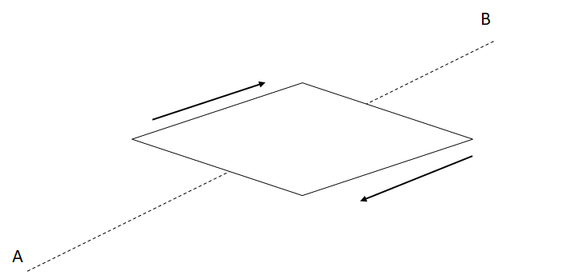

*Design of moving platforms*

## Timer

Each level will have a set amount of time to complete, depending on the difficulty of each level and the number of collectables of reach level. The countdown will start as soon as the player is able to control the tilt of the level.

## Bounce Platform

In certain levels, there will be a platform that will allow for the player object to be pushed depending on how the platform is angled. These bounce platforms will be designed so that they are visually distinct from the rest of the stage in those levels. When the player object moves onto a bounce platform, it will send the player up a certain distance. The height the bounce platform send the player object is static and will not increase or decrease regardless of how the player object interacts with the platform. The bounce platform will only push the player in one direction, depending on how the platform is angled. Though the player can affect where the player object goes if the player is applying tilt.

## 

*Example of the bounce pad being used in tandem with the tilt mechanic*

# Pause Menu

Anytime during gameplay, the player can press the escape key to pause the menu. Pressing the key will freeze all gameplay and bring up the pause menu. When the pause menu is active, the player will have three options. If the player presses the escape key again in the pause menu, it will resume the game. There are two buttons in the pause menu, the “Resume” button and the “Quit” button. The “Resume” button will resume the gameplay. The “Quit” button will bring the player back to the Level Select scene.

# Theme and General Look

## Theme

The theme of this game is simply: sci-fi space platformer but with a little twist. This outer space single-player features a cute hamster in his space uniform ready to go into space and carry out his mission. The theme of this game also features a “roll-the-ball” playing style for gathering all the collectables on each stage.

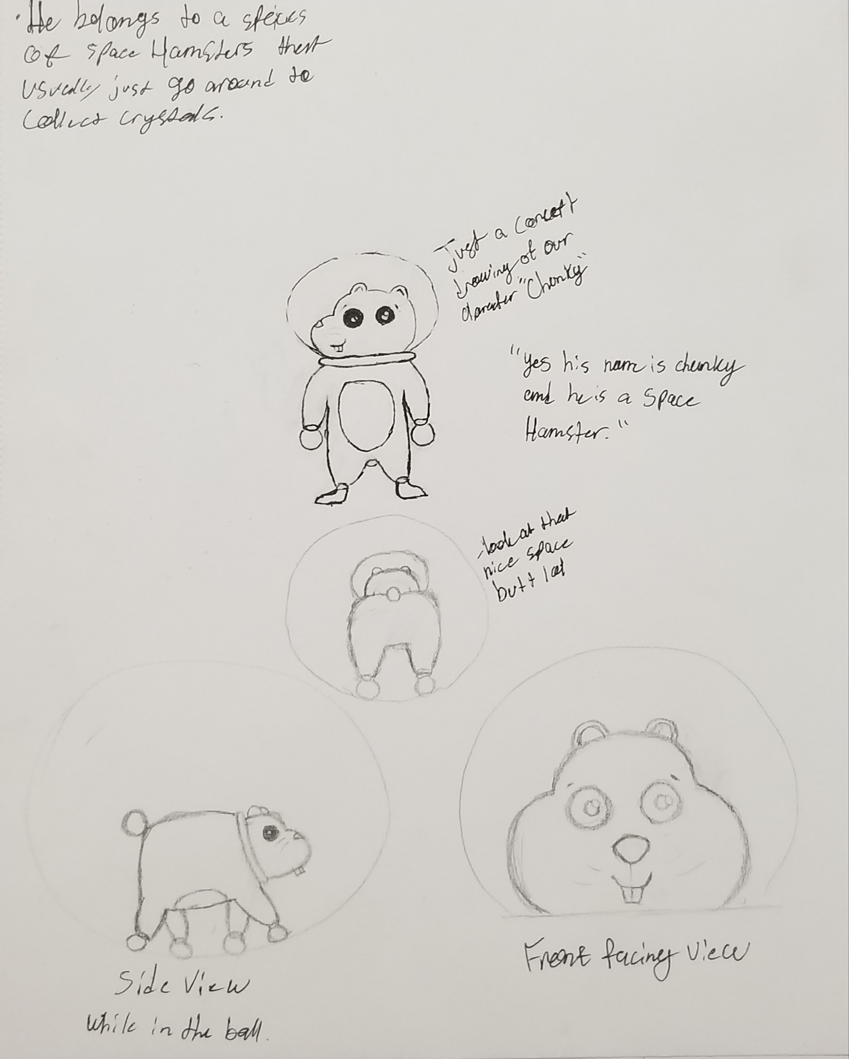

*Sketch designs of character*

## Art style

The game’s art style will be centered around a cartoonish style look. Our art style will be reminiscent of games from the late 90’s and early 2000’s . The environment for each set will be centered around sci-fi themes, as well as incorporating a cartoonish look for each level.

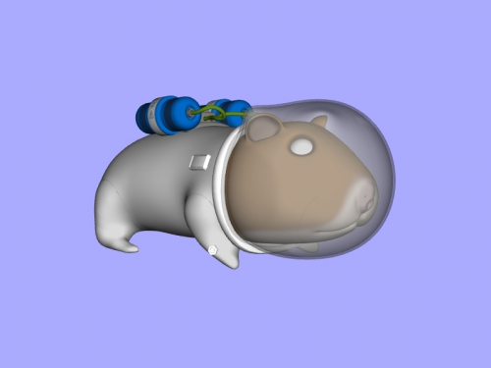

*Example of character model using a cartoon style*

# Game Flow

## Menu Flow Diagram

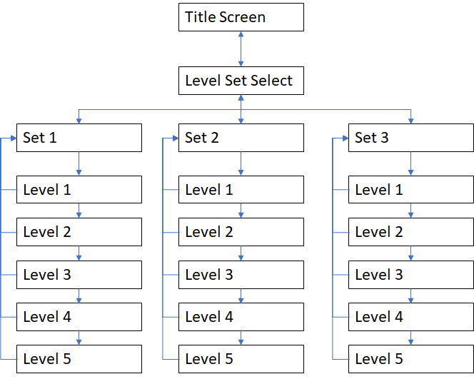

## Level Mock Up Example

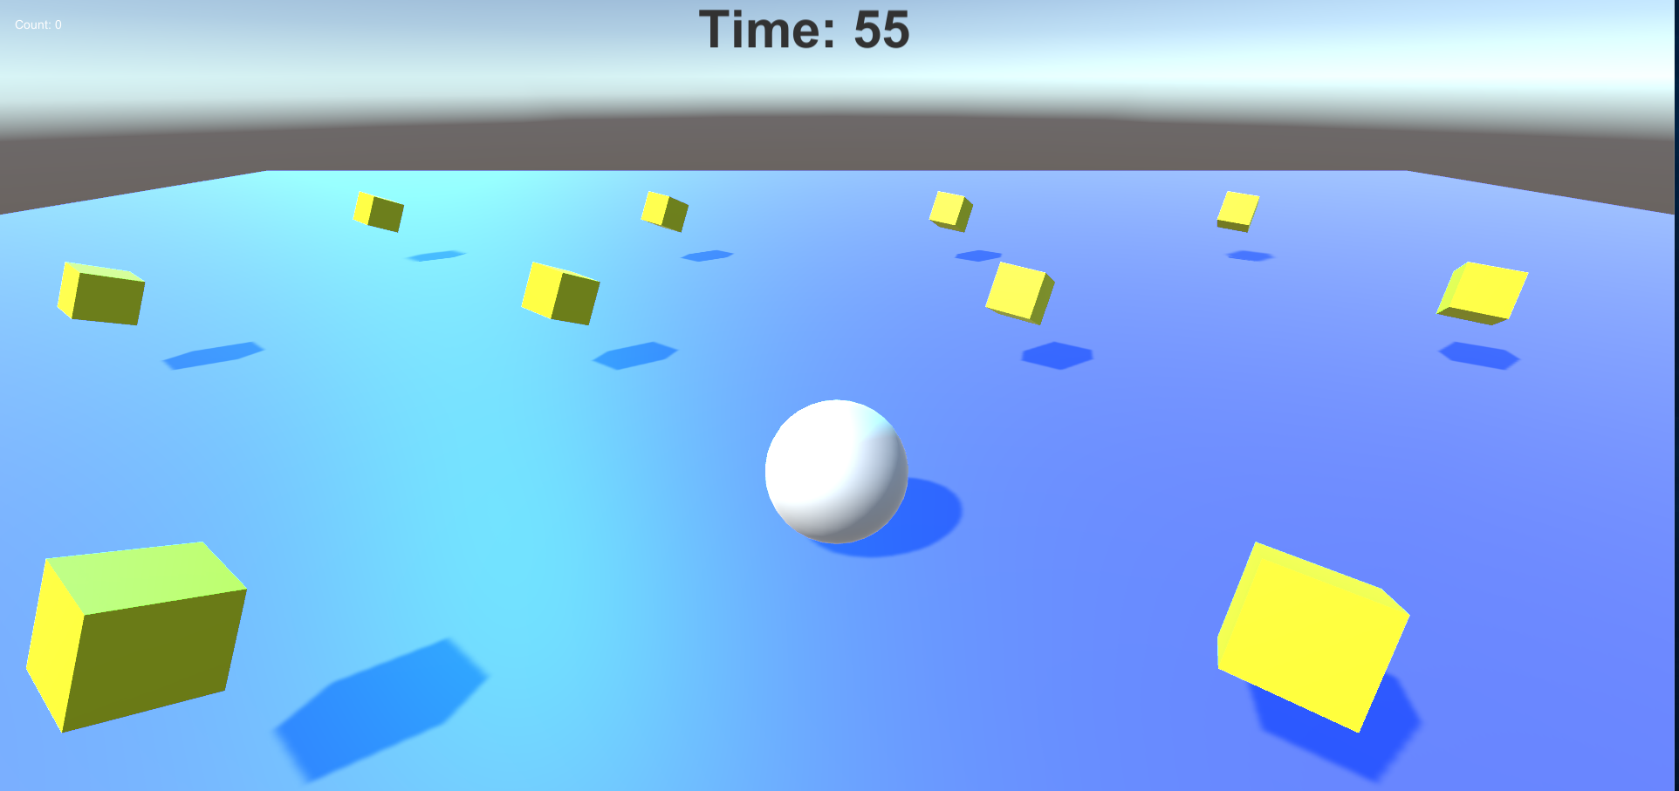

## Title Screen

The title screen will contain a designed image of the name of the game. Below the game’s name there will be three buttons stacked above and below each other. The top button will read “Play”, the button below the “Play” button will read “Instructions”, the button below the “Controls” button and the bottom button will read “Quit”. The “Play” button, when the player clicks on it, will bring the player to the “Level Set Screen”. The “Controls” button, when the player clicks on it, will bring up a box that contains instructions on how to play the game. The controls will contain an image of the control layout for keyboard and mouse as well as gamepad layout. When the player clicks on the “Quit” button, the game will close.

## Level Set Screen

In the Level Set Select screen, there will be four buttons. One button, placed on the top left corner of the screen, will read “Return to Title”. The “Return to Title” button will send the player back to the Title Screen. In the middle of the screen there will be three buttons placed side by side with each other. These buttons will be the “Level Set” buttons. Each Set contains several levels. When the player clicks on one of the “Level Set” buttons, it will bring the player to the “Level Select Screen” of the chosen Set.

## Level Select Screen

In the Level Select screen, there will be 16 buttons. One button, placed on the top left corner of the screen, will read “Return to Level Set Select”. The “Return to Level Set Select” will send the player back to the Level Set Select Screen. There are three title cards, each with a unique name and artwork to signify the set. Set 1 is called “Peaceful Odyssey. Set 2 is called “Grand Adventure” and Set 3 is called “The Void”. Underneath the three title cards there will be five “Level” buttons, each stacked above and below each other. The top button will read “Level 1” and the bottom button will read out “Level 5”. Selecting a Level button will bring the player to the specified level in the set.

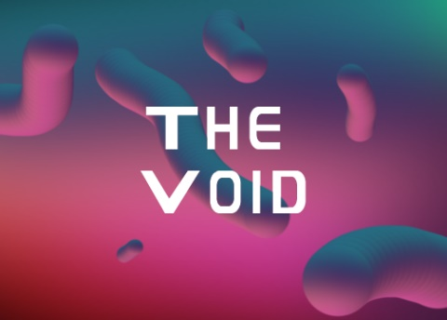

*Title cards for each level set*

# Approximate Timeline and Milestones

## Week 1

* Finish design document to begin work
* Begin development on major mechanics
* Begin creating designs for character and in-game objects

## Week 2

* Complete development of major mechanics
* Begin designing and implementing levels
* Start turning designs for characters and in-game objects into 3d
* Implement in-game objects

## Week 3

* Finish implementing levels
* Refine major mechanics if necessary
* Begin designing and implementing menus
* Begin QA testing
* At the end of Week 3 the game should be playable from start to finish

## Week 4

* Finish QA testing
* Fix any and all bugs
* Design a PowerPoint presentation for the game
* Be able to provide a working and complete version of the game

# Team Bio and Expected Contributions

* **Ajai Gorowara:**
  + Team Leader, Level Designer and Programmer
* **Christopher Reece:**
  + Programmer and Level Designer
* **Tyler Washington:**
  + Art Designer
* **Travis Qing:**
  + Programmer and Level Designer
* **Joshua Day:**
  + Art Designer